PEAK MAY AND ONWARD

*It’s high season for our housing developments: As of May 22nd, we had 28 nests in the golf course birdhouses; a rough count says there were at least 40 eggs in them (Eastern Bluebirds and Tree Swallows); and four of the boxes had hatched babies in various stages of development.
In the two weeks since then . . . most of those numbers have started to double, and triple. From here, it only accelerates. And so it goes.

*An exotic visitor: In mid-May, several club members began reporting (and photographing) a unique sight in the area of the 1st tee. Since then, he’s become an almost daily presence around the maintenance sheds, tees 1 and 10, and the general vicinity of the clubhouse.
It’s a Chukar Partridge. He’s almost definitely an escapee from a local gun club, according to speculation by a few locals who know that scene. It’s not a native to North America — introduced here from Asia, and found only out West (or on game farms for hunters). It’s also the national bird of Pakistan and Iraq! And apparently an amazing runner on the ground. . . .
He’s now such a club fixture that he’s getting named (John Stickles calls him “Putter”; I like “Starter,” as in, the guy who’s always on duty at a course’s 1st tee). Mark Anderson reports that the bird has scratched out a divot in the dirt near the gas pumps so he can take “dust baths,” which is one of the Chukar’s known habits. Check out more of the “Cool Facts” about our exotic new club member in this link.
https://www.allaboutbirds.org/guide/Chukar/overview
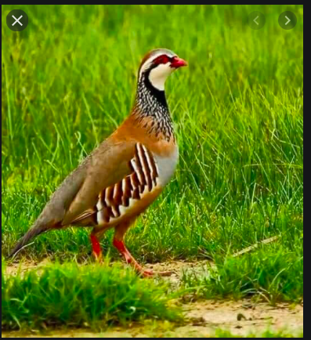

Chukar Partridge

*The curtain is coming down . . . on our Bald Eagles. The nest at the Braunstein estate, just off the 15th hole, has been “leafed in” — visibility from below is mostly obscured now. The last clear sighting I had of an adult eagle perched directly above the nest was on May 16th; our last known sightings of Mom sitting on the nest were in late April. If there were eggs (almost definitely yes), they’ve hatched; if there are hatchlings (we always hope), and if our math is right, they should fledge between now and mid-June. (The best info is that hatched Bald babies are in the nest for 8 to 12 weeks, or longer. A very wide range of time.) So from here, we have to wait and hope for sightings of adult and/or fledgling eagles going to or from the nest area. Spotting eagles flying around the lake and the club is always good, but . . . we’ll keep hunting for signals that those are “our” eagles.
*Random report . . . common enough, but a cool-looking bird, a migrant, probably nesting in brushy areas near the 14th hole: a Brown Thrasher. Check out that tail.

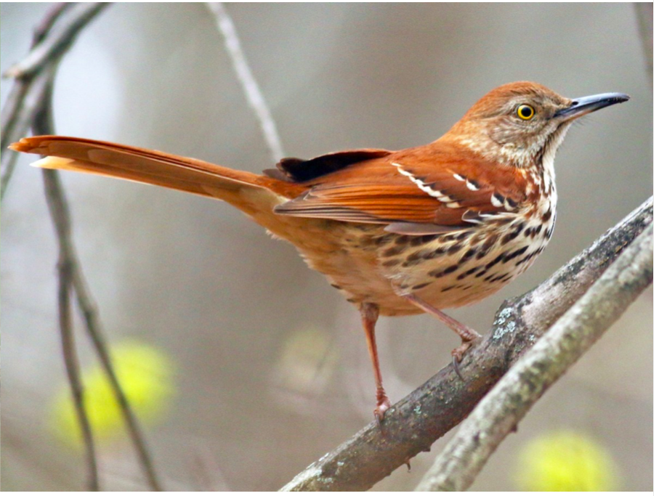
Brown Thrasher

*Hum along with us: A very popular visitor at flowering gardens and nectar feeders, probably right outside your door or even swirling near your head — the Ruby-throated Hummingbird. There are more than 20 different flavors of hummingbird that breed in or at least visit North America, but the only one that consistently travels to the eastern half of the continent to breed is the Ruby-throated.
Incredible tiny creatures of speed, endurance, beauty. We’ve put out two nectar feeders at the club (in the garden by 10th tee, and in the front garden), so keep eyes open — they’re blindingly fast, and they don’t linger.
Even though they’re the littlest kids in the class, Ruby-throats (females) are also fierce defenders of their nest sites, wherever those might be (featuring eggs the size of jelly beans).
There’s a ton of good backstory on hummers — here’s one source.
https://www.hummingbirdcentral.com/hummingbird-migration.htm

—Tom Walsh

